Task: 6: Automated Logging using Triggers & Views
Aim: To implement an automated logging system using database triggers that records every INSERT and UPDATE operation, and to generate daily activity reports using database views.
Algorithm:
- Start the program
- Insert or update employee data
- Trigger activates automatically on INSERT/UPDATE
- Store log details in logs table
- Fetch log data from database
- Use view to generate daily report
- Display logs and report on screen
- Stop the program
Program:
SQL:
CREATE DATABASE IF NOT EXISTS audit_db;
USE audit_db;
-- Employees table
CREATE TABLE employees (
id INT AUTO_INCREMENT PRIMARY KEY,
name VARCHAR(50),
salary INT
);
-- Logs table
CREATE TABLE logs (
log_id INT AUTO_INCREMENT PRIMARY KEY,
action VARCHAR(50),
emp_id INT,
emp_name VARCHAR(50),
time TIMESTAMP DEFAULT CURRENT_TIMESTAMP
);
-- Trigger: INSERT
CREATE TRIGGER after_insert_emp
AFTER INSERT ON employees
FOR EACH ROW
INSERT INTO logs(action, emp_id, emp_name)
VALUES ('INSERT', NEW.id, NEW.name);
-- Trigger: UPDATE
CREATE TRIGGER after_update_emp
AFTER UPDATE ON employees
FOR EACH ROW
INSERT INTO logs(action, emp_id, emp_name)
VALUES ('UPDATE', NEW.id, NEW.name);
-- VIEW (IMPORTANT — your previous error was here)
CREATE VIEW daily_report AS
SELECT DATE(time) AS date, action, emp_name
FROM logs
ORDER BY time DESC;

db.php:
<?php
$conn = new mysqli("localhost", "root", "", "audit_db");
if ($conn->connect_error) {
die("Connection failed: " . $conn->connect_error);
}
?>

activity.php:
<?php
include 'db.php';
// INSERT
if (isset($_POST['add'])) {
$name = $_POST['name'];
$salary = $_POST['salary'];
$conn->query("INSERT INTO employees(name, salary) VALUES('$name', '$salary')");
}
// UPDATE
if (isset($_POST['update'])) {
$id = $_POST['id'];
$salary = $_POST['salary'];
$conn->query("UPDATE employees SET salary='$salary' WHERE id='$id'");
}
// Fetch logs
$logs = $conn->query("SELECT * FROM logs");
// Fetch view
$report = $conn->query("SELECT * FROM daily_report");
?>
<!DOCTYPE html>
<html>
<head>
<title>Audit Logging System</title>
<style>
body { font-family: Arial; background: #f2f2f2; }
.box { width: 80%; margin: auto; background: white; padding: 20px; }
input, button { padding: 8px; margin: 5px; }
table { width: 100%; border-collapse: collapse; margin-top: 15px; }
th, td { border: 1px solid black; padding: 8px; text-align: center; }
h2 { color: blue; }
</style>
</head>
<body>
<div class="box">
<h2>Add Employee</h2>
<form method="POST">
<input type="text" name="name" placeholder="Name" required>
<input type="number" name="salary" placeholder="Salary" required>
<button name="add">Add</button>
</form>
<h2>Update Employee</h2>
<form method="POST">
<input type="number" name="id" placeholder="ID" required>
<input type="number" name="salary" placeholder="New Salary" required>
<button name="update">Update</button>
</form>
<h2>Logs (Trigger Output)</h2>
<table>
<tr><th>ID</th><th>Action</th><th>Employee</th><th>Time</th></tr>
<?php while($row = $logs->fetch_assoc()) { ?>
<tr>
<td><?php echo $row['log_id']; ?></td>
<td><?php echo $row['action']; ?></td>
<td><?php echo $row['emp_name']; ?></td>
<td><?php echo $row['time']; ?></td>
</tr>
<?php } ?>
</table>
<h2>Daily Report (View)</h2>
<table>
<tr><th>Date</th><th>Action</th><th>Employee</th></tr>
<?php while($row = $report->fetch_assoc()) { ?>
<tr>
<td><?php echo $row['date']; ?></td>
<td><?php echo $row['action']; ?></td>
<td><?php echo $row['emp_name']; ?></td>
</tr>
<?php } ?>
</table>
</div>
</body>
</html>

OUTPUT:
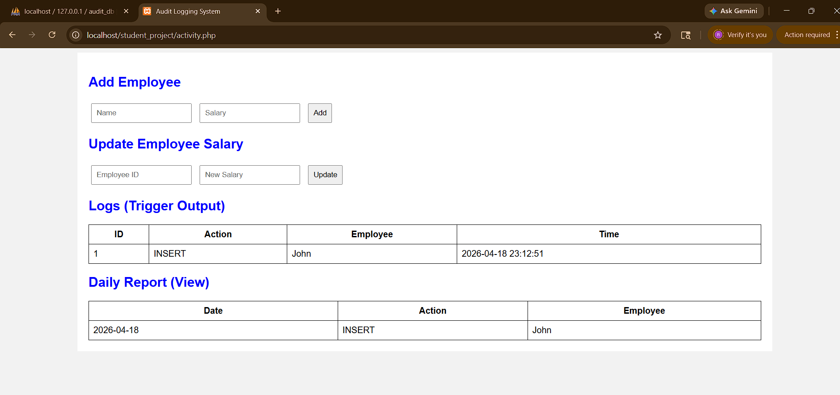

Result:
Thus, the Automated Logging using Triggers & Views is done successfully and output generated .

